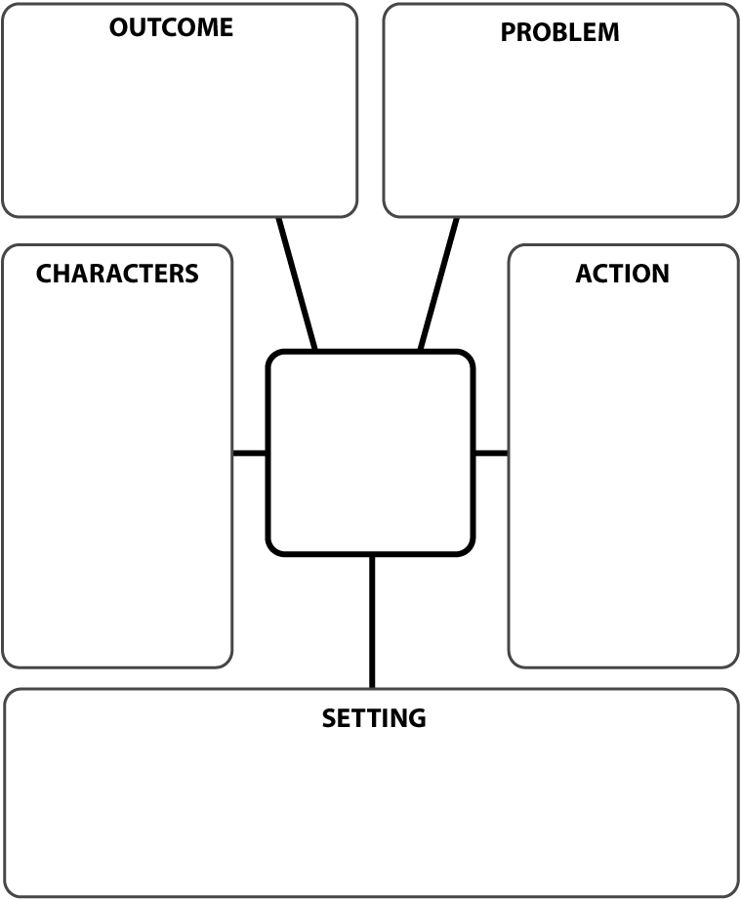

**Content Management System**

Help redesign the departmental website with faculty input

Create a site with better navigation, faculty information, syllabus, degree requirements, internship opportunities, advisement hours, news & announcements

Collaborate with CIS 228 students for redesign (Internship)

Collaborate with Career Services

Select and install content management system

Skin the content management system

Create tags for assets (Images, Videos, Pdf documents, JUnit Tests)

Manage Assets

Create and disperse credentials (User id & password)

Communication will allow for the services to grow and enhance.

Feedback from students can add or subtract features, faculty expertise can be shared in creating projects with the potential of uniformed grading

Check the online storage tool for project placed by students

Test JUnit cases against projects submitted by students & report grades to faculty

Creation of a website which will hold project grades and developments in the software industry

Select sites in which has a metric for assessment

Skin the site, or create navigation to methodology, projects, design, tools, resources, advisement, and tutorials

Update grades based on rubric & provide them to students

Have bi-monthly seminars on topics for software development, web design, portfolios and resumes

**Department Website**

**Web Portal**

**Test Box**

**ADMIN (TA)**

**Communication**